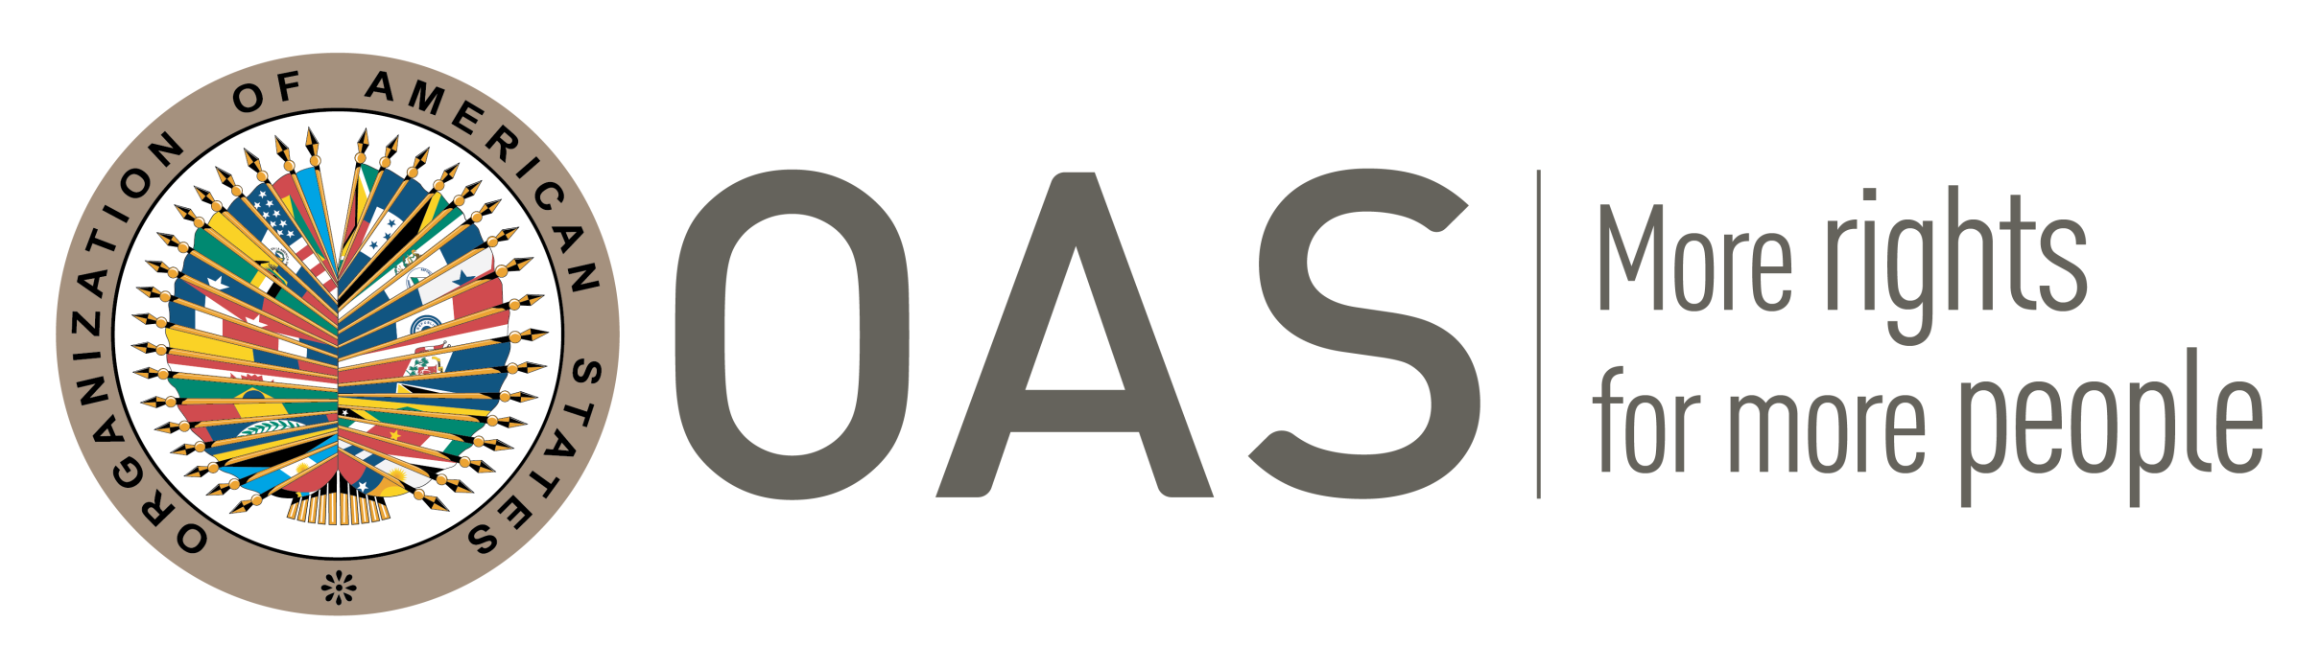
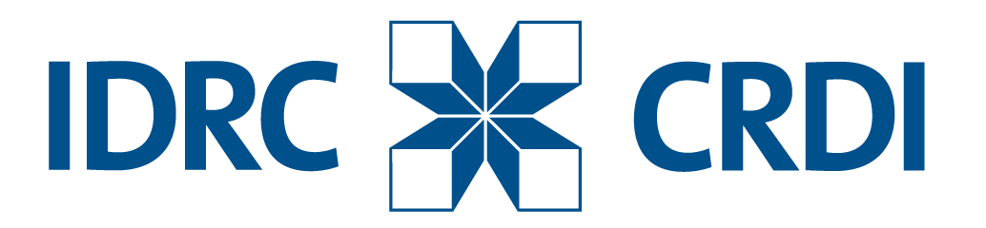

COUNTRY INITIATIVE
CLOSED SESSION - XIII ANNUAL CONFERENCE OF THE INGP
Santiago, Chile. October 5th, 2017

Caribbean Report

Introduction:

The period has been marked by increased efforts towards procurement reform to create an enabling environment facilitating greater efficiency, transparency and performance in our various islands and countries. With greater assistance from the partners such as the Caribbean Development Bank (CDB) and the World Bank, we have achieved some significant strides towards this strategic objective.
Notwithstanding, we continue to be challenged in various areas and would require technical assistance if we are to make a greater contribution towards the improvement of public procurement particularly in this Network.

Our report will focus on five key areas namely:
- Legislative Reform and Improvement
- Governance, Organizational Development and Institutional Support
- Technology including e GP and Open Data
- Capacity Building and Talent Development
- Shared/Common Challenges

Table 1: Summary of Procurement Legislation in the Caribbean
No. | NAME OF COUNTRY | EXISTING LEGISLATION
 | Montserrat | The procurement regulations 2012 have been reviewed with all stakeholders and sections for amendment agreed with Ministers. The 2017 regulations with amendments are being drafted for formal approval by Cabinet. These will be implemented in early 2018.
 | Cayman Islands | Procurement Law 2016 has been passed, assented and gazetted but is not yet in force. Procurement Regulations are at Cabinet awaiting approval. Planned implementation of Law & Regulations is early 2018.
 | Belize
 | Barbados
 | Jamaica
 | Suriname | The existing law is dated from 1954 and is part of the Accountability Act 1954. The government is aware of the transform it should do and a Working group has been installed to accomplish new legislation on this. Currently we are drafting a new Procurement Law and Regulations of which is planned to bring this draft law to Parliament by first quarter of 2018.
 | The Bahamas | Procurement Act is being drafted
 | Grenada | Public Procurement & Disposal of Public Property Act 2014 and Regulations 2015  Public Procurement (Review Commission) Regulations 2015  Public Procurement (Disposal Committee) Regulations 2015
 | Guyana | Procurement Act of 2003 and Regulations made under the Act (2004)
 | Turks and Caicos Islands | Public Procurement Ordinance enacted in November 2012. The Ordinance is a combination of law and regulations
 | St. Lucia | The Public Procurement and Asset Disposal Act was passed in November 2015. However, preparatory activities to promulgate the Act are currently being considered, including the governance and management structure. A consultant has been hired to assist with the drafting of the Implementing Regulations, which should start in November 2017. Until then, we continue to be guided by the Procurement and Stores Regulations under the Finance Administration Act of 2008.

INITIATIVE | DESCRIPTION
Legislative | Legislative reforms are being pursued by all Caribbean Countries at various levels. News laws are expected to be implemented between 2017-2019. In many cases revisions are being considered to include SMEs, Women and Vulnerable Groups. Implementing regulations and guidelines are being included to ensure greater transparency and accountability in public procurement.  Some islands are getting support from World Bank and DFID in this regard.
Governance and Organizational Structure | There are Policy Units and thresholds to guide strategic, operational and administrative functions for each country. Some countries in the region have proposed a restructuring to better support their individual country’s procurement functions. Procurement is housed under the Ministry of Finance in all jurisdictions except for the Turks and Caicos Islands where it is in the Office of the Deputy Governor.. While procurement continue to be a decentralized function in many instances, greater efforts have been placed on the strategic focus of procurement, development of governance structures to ensure greater oversight and inclusion of procurement planning as part of the Annual Budgeting process. This is to ensure the level of efficiency and to position the procurement function as part of the overall National Growth and Fiscal Reform Strategy. Many islands over the year have established procurement oversight and policy development units. Others like Jamaica continue to strengthen their units by planning to increase their personnel .Professionalization of procurement in the public service has either commenced or are planned in all Caribbean islands
Use of Technology | Most countries have advanced in the establishment of an e-tendering system which will be implemented upon approval of e-procurement provisions in the Act/Regulations/Ordinance, etc.  Guyana and Turks and Caicos Islands are now making preparations for e-procurement; Cayman Island and Montserrat has a fully functioning end-to-end e-tendering system. St. Lucia has just completed its e-procurement system which has been deemed satisfactory in its readiness. Support from the World Bank and DFID in establishing its e-GP platform has commenced with consideration for the requirements of the system. Preparations for the design, launch and maintenance of a web portal for an OECS Procurement Network are currently underway. Requirements for the design of the network are being finalized. Saint Lucia has agreed to host the Network at least for the first two years. Support for this network is being given by CDB and the World Bank. St Lucia , Turks and Caicos Islands and Grenada use the official government websites to publish procurement information
Capacity Building and Development | All countries are currently undertaking extensive capacity building initiatives including training of Senior and Mid-management procurement practitioners.  CDB is supporting an initiative to pilot a program at Jamaica University of Technology – Regional Procurement Centre. Barbados continues to host its Associate Degree in Procurement at its Community College. Some islands have achieved training in CISPS up to level 4. In house training continues as well as use of training opportunities from OAS and other agencies

Common Challenges:

- Capacity Building
As we seek to professionalize procurement in the Caribbean region, it is imperative that we train and develop the competencies of persons performing procurement functions. Curriculum development, technical training, management training in all areas are required, using various modalities (face-to-face, virtual, online etc). Training at various certification levels are required.

- Institutional Strengthening

The current institutional arrangements pose some impediments to successful procurement reform. The structure, work flows, processes and operations of some institutions within the public service create limitations to reform efforts. Assistance to streamline institutions, process review and re-engineering, standardization of bid documents and processes are strengthening of the units and departments along the procurement cycle are key requirements for all the islands and countries

- Research and Development

The region does not possess baseline information to assess current procurement outcomes, nor to make evidence based decisions in this regard. Many decisions are made on other factors which are not very sustaining. Technical assistance to assess, review and analyze our procurement activities would be required

- New Initiatives and Change Management

Successful procurement reforms in the Caribbean would require assistance to manage the changes and to gain the buy-in from stakeholders at all levels of the continuum. Assistance to undertake the extensive engagements to include but not limited to meetings, conferences and focus groups is paramount. Changes in processes, documentation, operations, legislation are but a few areas.

